ECEN-361 Lab-05:SPI & Logic Analyzer

NAME: ___________________________________

Introduction and Objectives of the Lab
This lab will require very little code development. The project as cloned from the GitHub-Classroom, runs without modification. You’ll be asked to use a logic analyzer to capture traces of the formats and compare their utility.

- Part 1: Physical observation of different digital serial communication protocols: I2C, SPI, and UART
- Part 2: Become familiar with a logic analyzer, capture & decoding capabilities.

For each of the parts, follow the instructions, then fill in answers to the questions. Expected answers are indicated in the boxes with red text/spaces to fill in answers.

Lab Instructions

Part 1: Accept the Assignment, Download the repo, Run it

Accept the Assignment, Download the repo, Run it

Same procedure as previous labs – get the laboratory into your STM32CubeIDE workspace, then clean/build/run it.
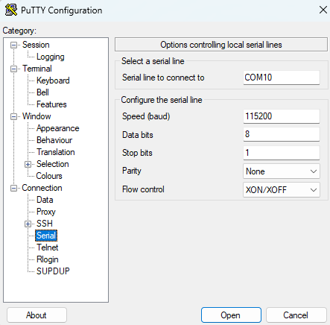
In order to interact with the program, you’ll need to bring up a serial terminal emulator, like PuTTY (windows) or screen (MAC). Terminal emulator specs are (always the same for this class):

Your COM: port will be found with DeviceManager or on a MAC as (/dev/tty…)

With a terminal emulator running you’ll see the opening banner and a prompt to enter a line of text:

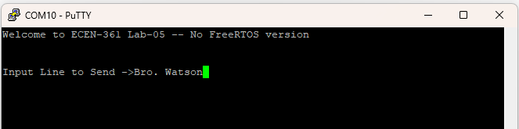

Install the Saelae Logic Analyzer Software: Logic 2

Connect and label the probes for the SPI, UART and I2C:
To probe the SPI and I2C pins, you’ll use the following:

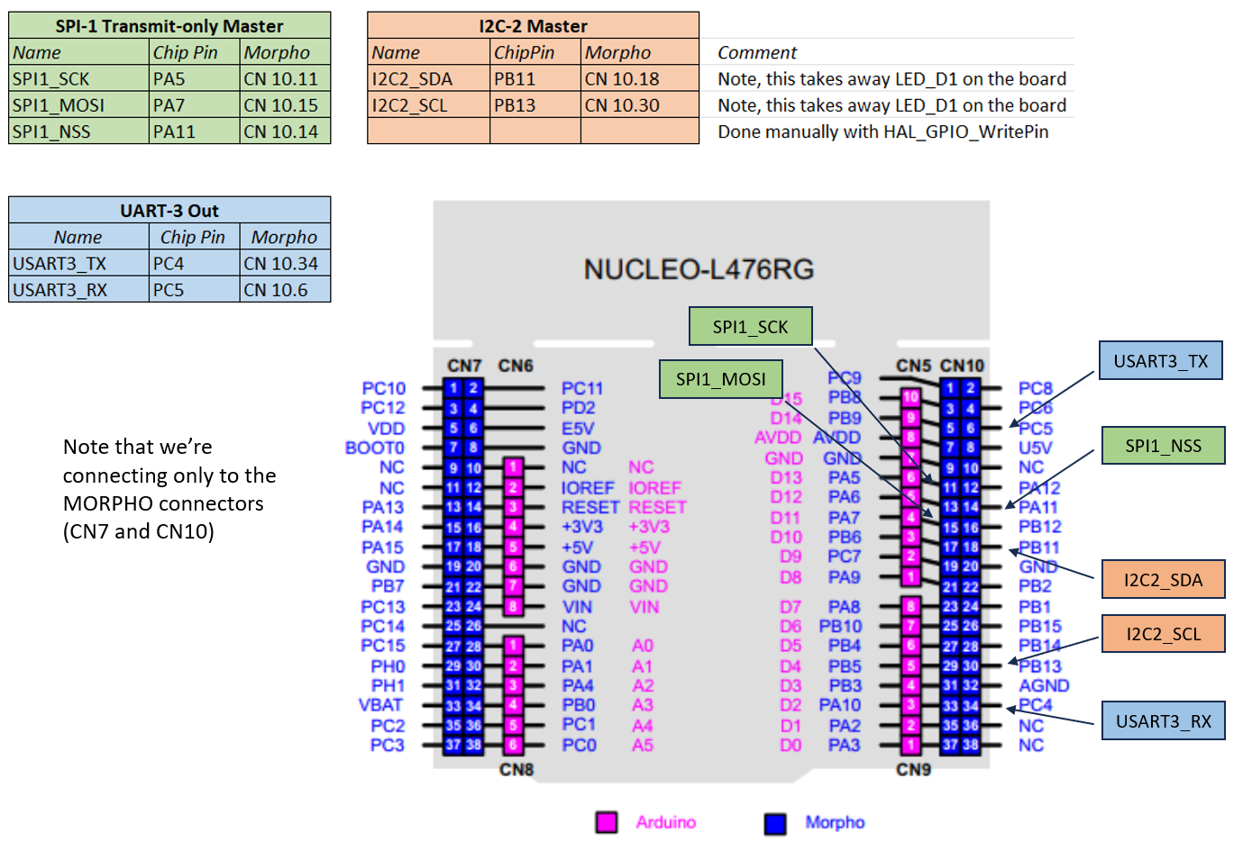
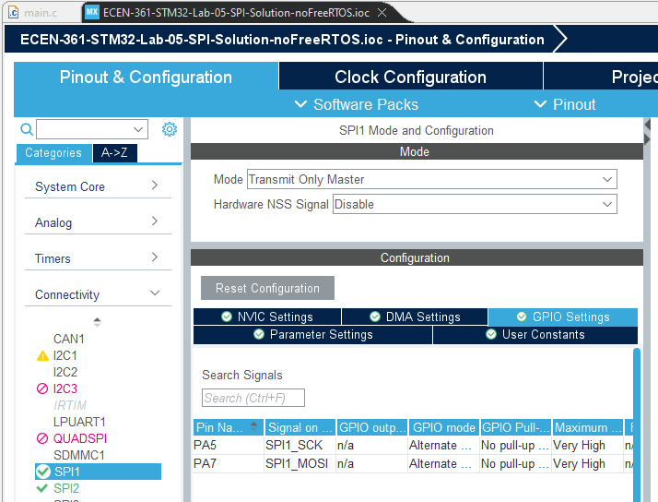
Note that these pins are found from the STMCubeIDE configuration file. Opening will show (SPI1 for example):

Connectivity / GPIO Settings:

You’ll manually change, configure I/O pins later and in other labs.

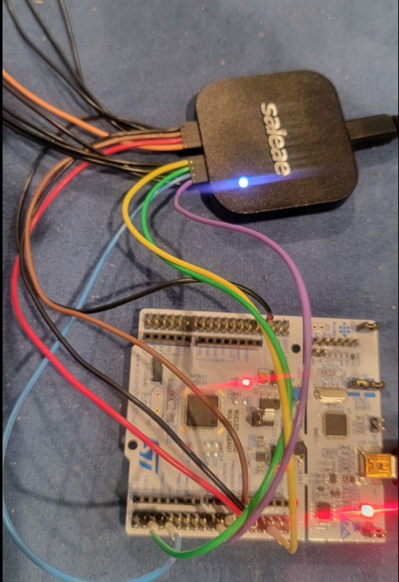
Plug in the logic analyzer and run the “Logic 2” program.

Connect probes from the Saelae Logic, using:
- GND (Black pins are on bottom)
- SPI1_SCK
- SPI1_MOSI
- SP1_NSS

Label them in the software. Make sure the inputs are Digital

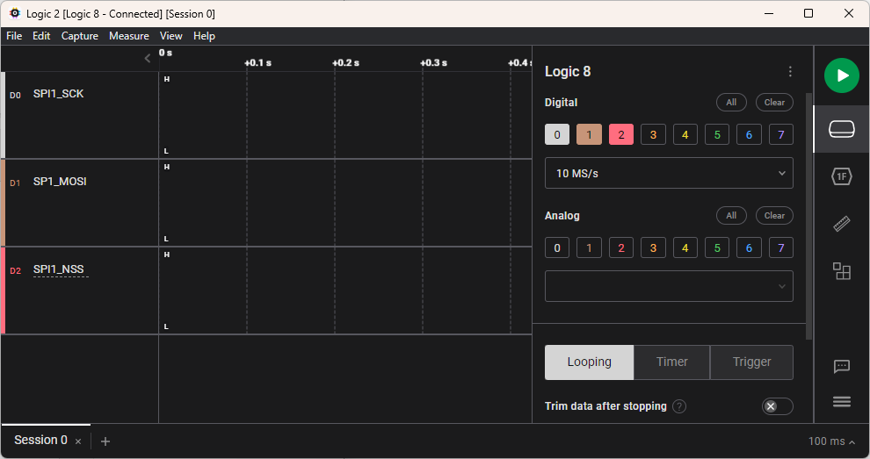

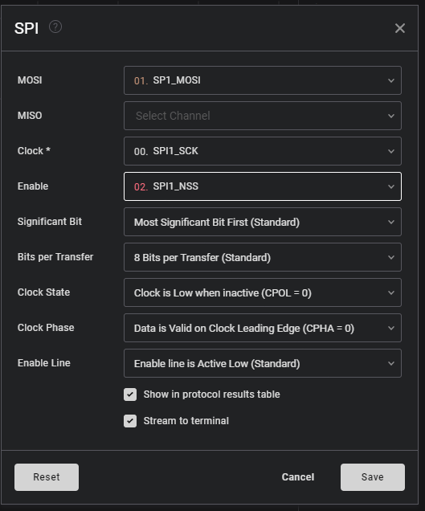
Program the Analyzer to decode SPI:

Set the mode to trigger on the falling edge of SPI1_NSS:

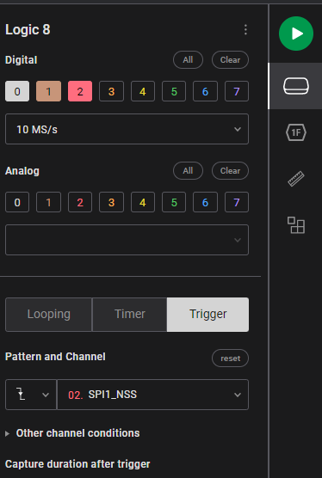

- Run a capture on the Logic2 (big green button)
- Enter some TXT into the TTY emulator
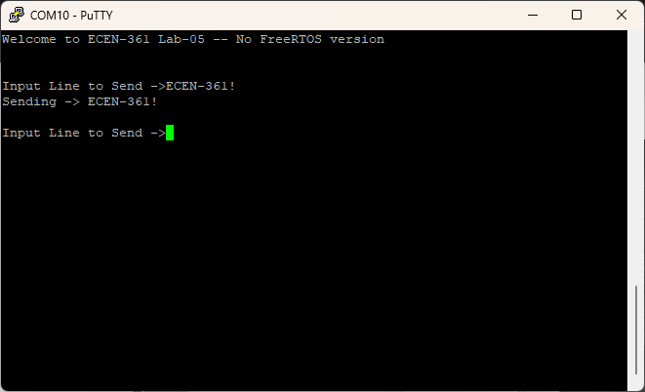
- Look at the results. Change the output formatting to be ASCII

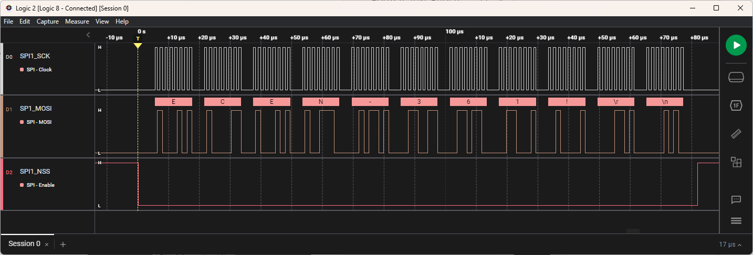
Experiment with this, send different codes, learn to use the tool, then answer the following questions:

SPI-PART-1 3 Pts.

- What is the default bitrate? (time per bit) -- Use the measurement tool (looks like a ruler)
_____________________________________________________
- How much time between each byte? ___________________________________

- Which has more overhead: USART or SPI? And why?
_____________________________________________________
The transfer rate is a function of a clock divider on the main clock (80Mhz). Default in your code is 128. Find the line that defines this: hspi1.Init.BaudRatePrescaler = SPI_BAUDRATEPRESCALER_128; rate in main.c. Change this line to make the SPI transfer as fast as possible, compile, run, and capture the results and note what you see.

SPI_Par6t

- What is fastest bit rate possible with this processor? Equation?
_______________________________________________________________

- Is there any problem capturing the fastest data of a USART channel?
___________________________________

Part 2: Doing the same with the UART2 –

Attach the I2C Signals to look at the data coming out, then answer:

3 Pts.

- What is the default bitrate? (time per bit) -- Use the measurement tool (looks like a ruler)
_____________________________________________________
- How much time between each byte? ___________________________________
- What is the value of the data coming out first? It’s not like the others.
_____________________________________________________

Part 3: Doing the same with the UART2 –

Attach the USART3_TX and RX and sample again, looking at the data coming out, then answer:

2 Pts.

- What is the default bitrate? (time per bit) -- Use the measurement tool (looks like a ruler)
_____________________________________________________
- What is the max bitrate easily supported? ___________________________________

Extra Credit Fun Ideas

Reference

5 Pts. Max, for completing any of these (or thinking of your own)

- Add on the MultiFunction Board, and have it display the number of characters sent each time.
- Enable SPI2, as shown in the table above (thru the .IOC configuration file), and read code that gets sent from SPI1->SPI2

- Currently SPI is running in “blocking” (polled) mode. Change it to run via an interrupt so the processor could be more efficient.

- Enable a ‘smart’ trigger on the Logic Analyzer so it doesn’t actually begin capturing data until specific data is decoded/found.

To Finish

When completed with everything, commit/push the repo, and submit the URL of the checked-in repo to the iLearn Lab submission assignment. For any extra-credit, document it as appropriate, a small paragraph, a video clip, etc.

The following is a capture of all three protocols.
Notes that you’ll need:
- The LogicAnalyzer can apply different protocols to different signals. In this case all three are shown
- I2C in master mode first transmits the address (here it’s 0x11), then waits for the ACK to send the data. Without a SLAVE no data is actually sent.
- The UART is much slower and has overhead of start/stop bits.
